SEKRETARIAT KURSUS
FUTURES THINKING AND SCENARIO PLANNING (INTERMEDIATE) 2/2023

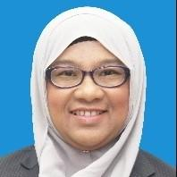
NURAIZAH BINTI MOHD ZAM
03-2084 7669
nuraizah@intanbk.intan.my

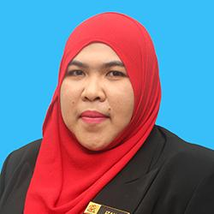
NOR IZANA BT ABDUL KARIM
03-2084 7307
izana@intanbk.intan.my

